Install Ansible
1 - python3 -m pip -V
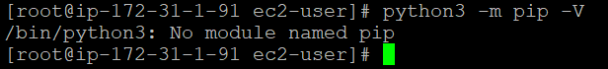
2 - yum install python3-pip
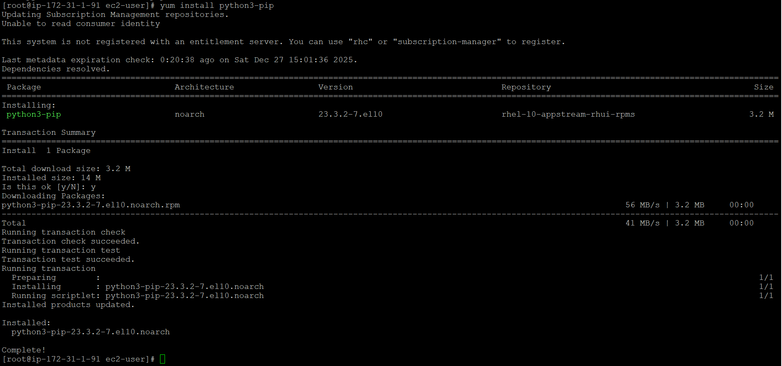
3 - dnf install -y ansible-core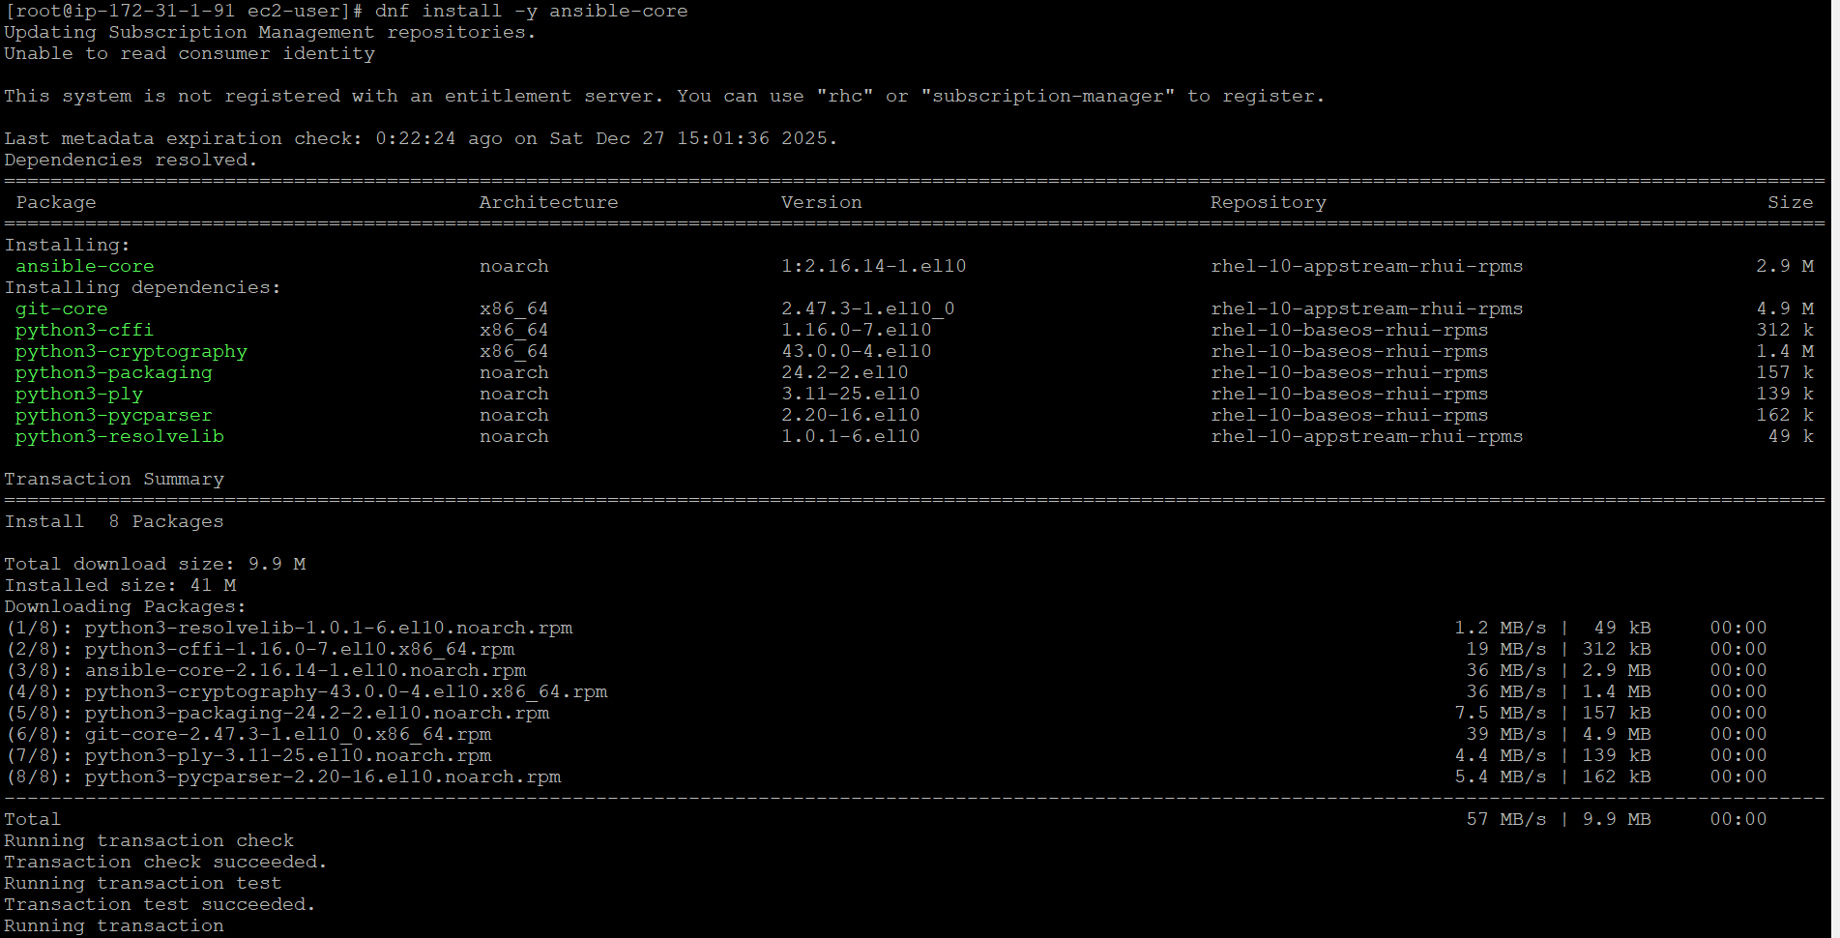
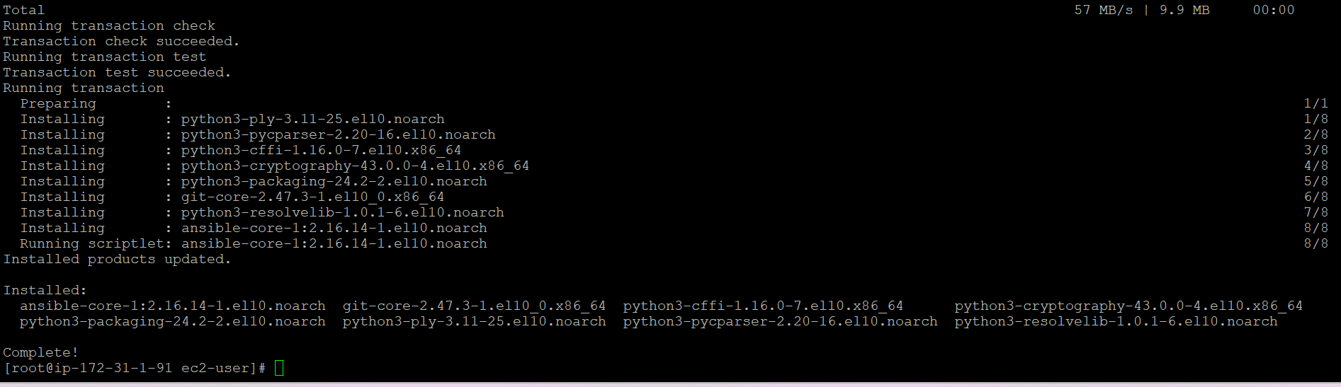
4 – ansible –version
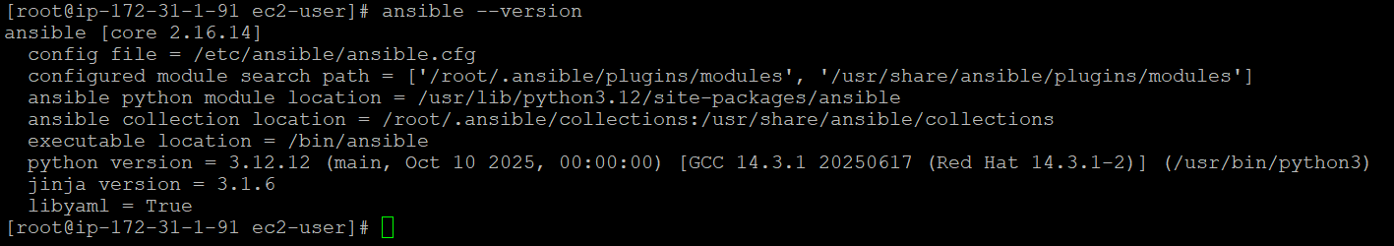
For upgrading Ansible run below command
5 - python3 -m pip install --upgrade --user ansible
Connect to EC2 instance
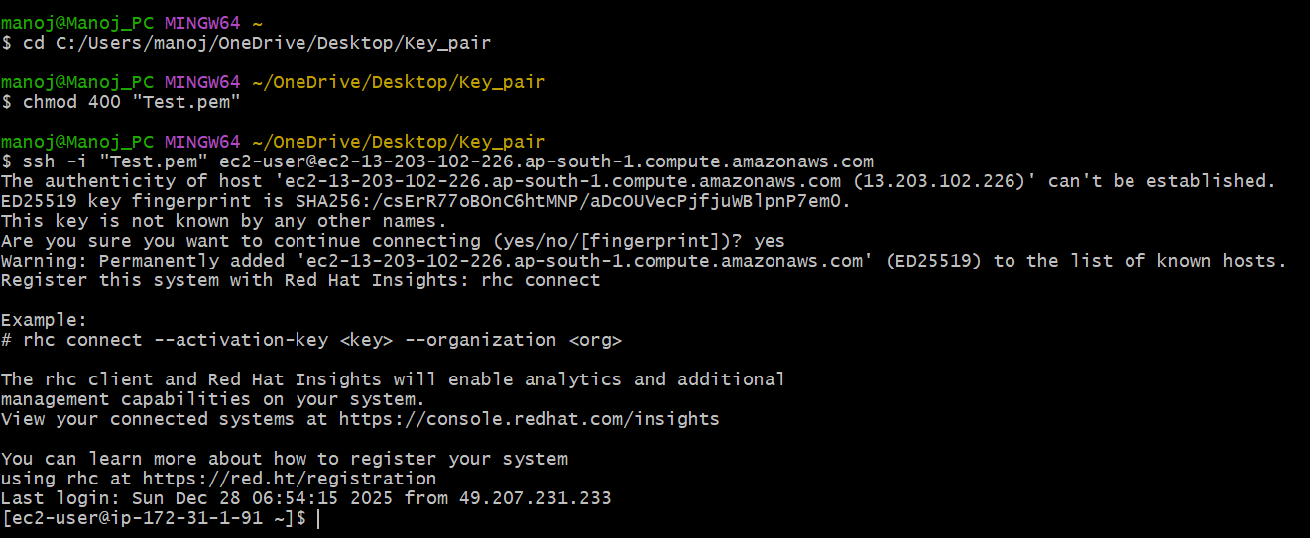
ansible localhost -m setup --connection=local
ansible localhost -m shell -a "uptime" --connection=local
ansible localhost -m file -a "dest=/tmp/new_dir mode=755 state=directory" --connection=local
ansible localhost -m copy -a "src=./local_file.txt dest=/tmp/remote_file.txt" --connection=local

